AN ATTENTION ENHANCED BIDIRECTIONAL LSTM FOR EARLY FOREST FIRE SMOKE RECOGNITION
ABSTRACT

Detecting forest fire smoke during the initial stages is vital for preventing forest fire events. Recent studies have shown that exploring spatial and temporal features of the image sequence is important for this task. Nevertheless, since the long distance wildfire smoke usually move slowly and lacks salient features, accurate smoke detection is still a challenging task. In this paper, we propose a novel Attention Enhanced Bidirectional Long Short-Term Memory Network (ABi-LSTM) for video based forest fire smoke recognition. The proposed ABi-LSTM consists of the spatial features extraction network, the Bidirectional Long Short-Term Memory Network (LSTM), and the temporal attention sub network, which can not only capture discriminative spatiotemporal features from image patch sequences but also pay different levels of attention to different patches. Experiments show that out ABi-LSTM is capable of achieving best accuracy and less false alarms on different types of scenarios. The ABi-LSTM model achieve a highly accuracy of 97.8%, and there is 4.4% improvement over the image-based deep learning model

PROPOSED SYSTEM
The proposed ABi-LSTM is mainly composed of three components: the spatial features extraction network, the Bidirectional LSTM network, and the temporal attention subnetwork. The spatial features extraction network is employed to extract spatial features from candidate patches, which are captured by ViBe background subtraction method. The Bidirectional LSTM network learns long-term smoke-related information from spatial features. In order to make full use of both the past and future context information of a sequence in classification, a bidirectional LSTM is employed to extract temporal features from forward and backward order. In this model, the orange arrows indicate the direction of information flow in forward LSTM and the blue arrows indicate the direction of information flow in backward LSTM. In order to concentrate on discriminative frames which contribute more on forest fire smoke recognition, an attention subnetwork is designed to automatically emphasize motion information with a soft attention mechanism in temporal domain.

PROPOSED TECHNIQUE
- LSTM NETWORK
- V3 NETWORK

PROPOSED SYSTEM ADVANTAGES
- High accuracy.
- Performance is high.

PROPOSED SYSTEM BLOCK DIAGRAM

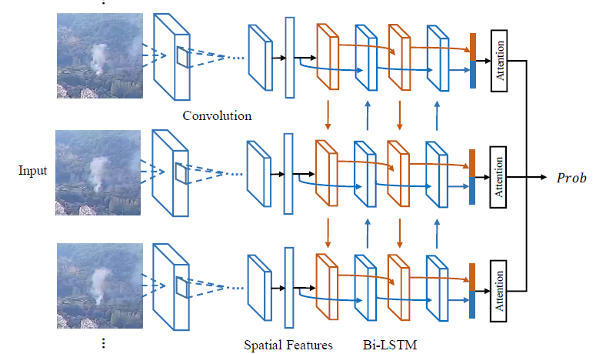

FIG 1.1: DETAILED BLOCK DIAGRAM OF PROPOSED SYSTEM

Hardware Requirements
The necessary hardware regarding private PC that comprises configuration as specified as follows:-
1. Processor: Intel core i3/i5.
2. Disk capability: 1GB for MATLAB only.
3. RAM: 2GB.

Software Tool used
The necessary program regarding private PC that comprises configuration as specified as follows:-
1. Windows 7(64-bit) operating system.
2. MATLAB version R2012a.

Image Processing Toolbox
Image processing device box permits carrying out image improvement, deblurring of image, characteristic identification, decreasing of noise, image segmentation, arithmetical alteration, as well as registration of image. Image processing device intended for the execution regarding methods proposed are specified below:-
1. Fundamental import as well as export
2. Display

Features of MATLAB

- Interactive background meant for aim investigation as well as resolving the difficulty.
- MATLAB is a sophisticated language intended for creating, calculating as well as building up a purpose.
- It contains numerical tasks such as figures, calculus, sorting out, developments, mathematical integration, as well as working out equations.
- Graphics integrated intended for visualization.
- Intended for generating traditional plot integrated equipments is accessible.
- Troubles as well as way outs are given in well-known numerical symbol.

