IMPROVING SHADOW SUPPRESSION FOR ILLUMINATION
ROBUST FACE RECOGNITION

ABSTRACT
2D face analysis techniques, such as face land marking, face recognition and face verification, are reasonably dependent on illumination conditions which are usually uncontrolled and unpredictable in the real world. The current massive data-driven approach, e.g., deep learning-based face recognition, requires a huge amount of labeled training face data that hardly cover the infinite lighting variations that can be encountered in real-life applications. An illumination robust preprocessing method thus remains a very interesting but also a significant challenge in reliable face analysis. In this paper we propose a novel model driven approach to improve lighting normalization of face images. Specifically, we propose to build the underlying reflectance model which characterizes interactions between skin surface, lighting source and camera sensor, and elaborate the formation of face color appearance. The proposed illumination processing pipeline enables generation of the Chromaticity Intrinsic Image (CII) in a log chromaticity space which is robust to illumination variations. Moreover, as an advantage over most prevailing methods, a photo-realistic color face image is subsequently reconstructed, which eliminates a wide variety of shadows whilst retaining the color information and identity details. Experimental results under different scenarios and using various face databases show the effectiveness of the proposed approach in dealing with lighting variations, including both soft and hard shadows, in face recognition.

PROPOSED SYSTEM

Here in this work, we propose a novel model driven-based lighting normalization approach for the purpose of lighting variation robust 2D face recognition. Specifically, we first divide the whole face into highlighted and non-highlighted regions. Second, we approximate Lambertian surfaces and Planckian lighting in order to investigate image formation rules. Then, a pixel-level transformation in log space is constructed with a view to pursuing a chromaticity invariant representation. The final step is to extend this chromaticity invariance to color space by taking shadow edge detection into account. Ultimately, the experiments are carried out based on lighting normalized images, and favorable experimental results have been achieved on the CMU-PIE and the FRGC face database.

PROPOSED SYSTEM ADVANTAGE
- Performance is high.

PROPOSED SYSTEM BLOCK DIAGRAM

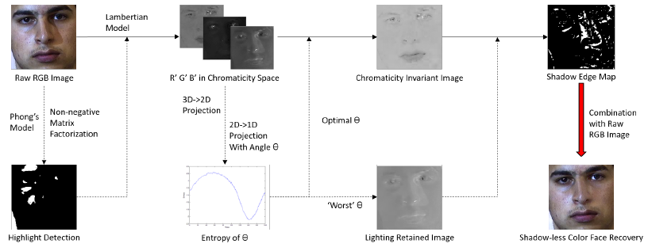

FIG 1.1: DETAILED BLOCK DIAGRAM OF PROPOSED SYSTEM

Hardware Requirements
The necessary hardware regarding private PC that comprises configuration as specified as follows:-
1. Processor: Intel core i3/i5.
2. Disk capability: 1GB for MATLAB only.
3. RAM: 2GB.

Software Tool used
The necessary program regarding private PC that comprises configuration as specified as follows:-
1. Windows 7(64-bit) operating system.
2. MATLAB version R2012a.
Image Processing Toolbox
Image processing device box permits carrying out image improvement, deblurring of image, characteristic identification, decreasing of noise, image segmentation, arithmetical alteration, as well as registration of image. Image processing device intended for the execution regarding methods proposed are specified below:-
1. Fundamental import as well as export
2. Display

Features of MATLAB

- Interactive background meant for aim investigation as well as resolving the difficulty.
- MATLAB is a sophisticated language intended for creating, calculating as well as building up a purpose.
- It contains numerical tasks such as figures, calculus, sorting out, developments, mathematical integration, as well as working out equations.
- Graphics integrated intended for visualization.
- Intended for generating traditional plot integrated equipments is accessible.
- Troubles as well as way outs are given in well-known numerical symbol.

