A LARGE-SCALE DATABASE AND A CNN MODEL FOR ATTENTION-BASED GLAUCOMA DETECTION

ABSTRACT
Glaucoma is one of the leading causes of irreversible vision loss. Many approaches have recently been proposed for automatic glaucoma detection based on fundus images. However, none of the existing approaches can efficiently remove high redundancy in fundus images for glaucoma detection, which may reduce the reliability and accuracy of glaucoma detection. To avoid this disadvantage, this paper proposes an attention-based convolutional neural network (CNN) for glaucoma detection, called AGCNN. Specifically, we first establish a large-scale attention-based glaucoma (LAG) database, which includes 11,760 fundus images labeled as either positive glaucoma (4,878) or negative glaucoma (6,882). Among the 11,760 fundus images, the attention maps of 5,824 images are further obtained from ophthalmologists through a simulated eye-tracking experiment. Then, a new structure of AG-CNN is designed, including an attention prediction subnet, a pathological area localization subnet and a glaucoma classification subnet. The attention maps are predicted in the attention prediction subnet to highlight the salient regions for glaucoma detection, under a weakly supervised training manner. In contrast to other attention-based CNN methods, the features are also visualized as the localized pathological area, which are further added in our AGCNN structure to enhance the glaucoma detection performance. Finally, the experiment results from testing over our LAG database and another public glaucoma database show that the proposed AG-CNN approach significantly advances the state-of-the-art in glaucoma detection.

PROPOSED SYSTEM

Here in this work, we propose AG-CNN architecture which has two 2 stages as follows. In the first stage, the ROI of glaucoma detection is learned from the attention prediction subnet, aiming to predict human attention on diagnosing glaucoma. It is because Findings 1 and 2 show that glaucoma diagnosis is highly related to small ROI regions. In addition, the multiscale building block is also included in our AG-CNN model, because Finding 3 shows that ROIs for glaucoma diagnosis are of different scales. In the second stage, the predicted attention map is embedded in the pathological area localization subnet, and then the feature map of this subnet is visualized to locate the pathological area. It is because the CNN may extract some pathological areas that are not obvious for the diagnosis by ophthalmologists. Finally, the located pathological area combined with the predicted attention map is further used to mask the input and features of the glaucoma classification subnet, for outputting the binary labels of glaucoma. The main structure of AG-CNN is based on residual networks, in which the basic module is a building block. Note that all convolutional layers in AG-CNN are followed by a batch normalization layer and a ReLU layer for increasing the nonlinearity of AG-CNN such that the convergence rate can be accelerated. The process of training AG-CNN is in an end-to end manner with three parts of supervision: attention prediction loss, feature visualization loss and glaucoma classification loss.

PROPOSED TECHNIQUE
- AG-CNN

PROPOSED SYSTEM ADVANTAGES
- Improve the performance of glaucoma detection
- Pathological area localization in our AG-CNN method is far better than other state-of-the-art methods.

PROPOSED SYSTEM ARCHITECTURE

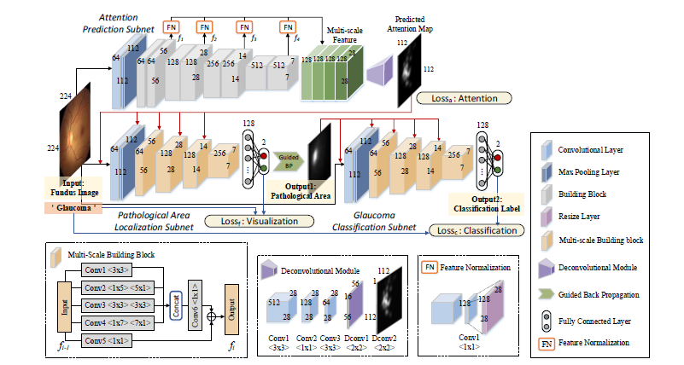

FIG 1.1: DETAILED ARCHITECTURE OF PROPOSED SYSTEM

Hardware Requirements
The necessary hardware regarding private PC that comprises configuration as specified as follows:-
1. Processor: Intel core i3/i5.
2. Disk capability: 1GB for MATLAB only.
3. RAM: 2GB.

Software Tool used
The necessary program regarding private PC that comprises configuration as specified as follows:-
1. Windows 7(64-bit) operating system.
2. MATLAB version R2012a.
Image Processing Toolbox
Image processing device box permits carrying out image improvement, deblurring of image, characteristic identification, decreasing of noise, image segmentation, arithmetical alteration, as well as registration of image. Image processing device intended for the execution regarding methods proposed are specified below:-
1. Fundamental import as well as export
2. Display

Features of MATLAB

- Interactive background meant for aim investigation as well as resolving the difficulty.
- MATLAB is a sophisticated language intended for creating, calculating as well as building up a purpose.
- It contains numerical tasks such as figures, calculus, sorting out, developments, mathematical integration, as well as working out equations.
- Graphics integrated intended for visualization.
- Intended for generating traditional plot integrated equipments is accessible.
- Troubles as well as way outs are given in well-known numerical symbol.

